Experiment 1.3

# Student Name: Rahul Kumar UID: 20BCS7081

**Branch: BE-CSE Section/Group:20BCS_DM-716 B**

# Semester: 6 Date of Performance: 06/03/23

**Subject Name: IOT LAB Subject Code: 20CSP_358**

# Aim:

Demonstration of Autodesk Tinkercad Simulation Platform.

# Objective:

* + Learn about IoT based simulations.
  + Testing and model in IoT based simulation platform.

# Code-Output:

* + Hardware Requirement
    - Arduino Uno
    - Ultrasonic

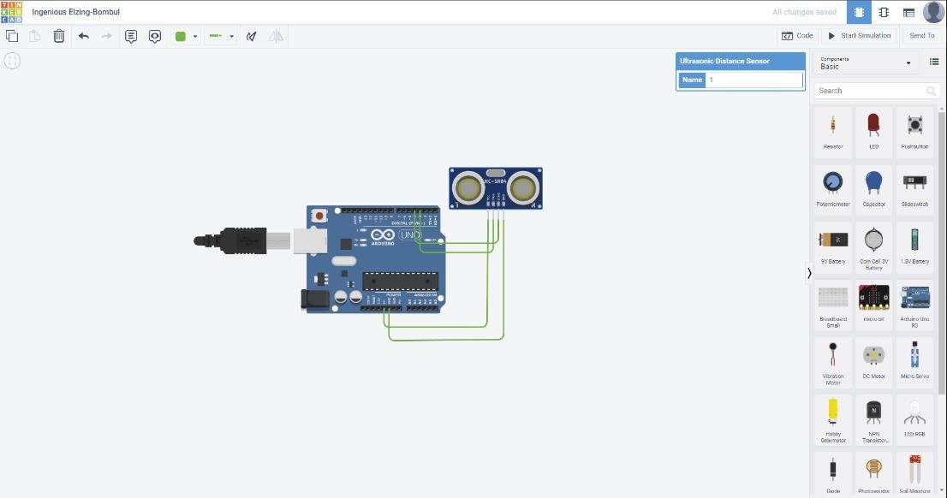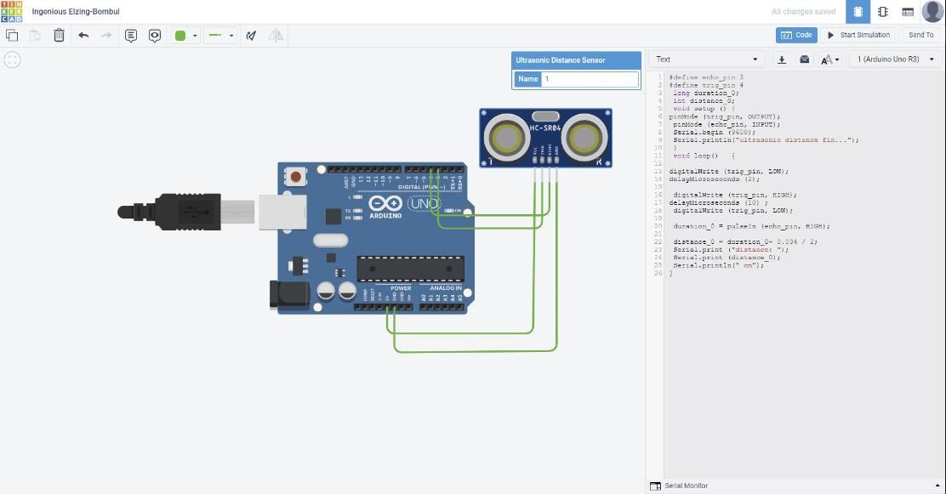

#define echo_pin 3

#define trig_pin 4 long duration_0; int distance_0; void setup () {

pinMode (trig_pin, OUTPUT); pinMode (echo_pin, INPUT); Serial.begin (9600);

Serial.println("ultrasonic distance fin...");

}

void loop() {

digitalWrite (trig_pin, LOW); delayMicroseconds (2); digitalWrite (trig_pin, HIGH); delayMicroseconds (10) ; digitalWrite (trig_pin, LOW);

duration_0 = pulseIn (echo_pin, HIGH); distance_0 = duration_0+ 0.034 / 2; Serial.print ("distance: ");

Serial.print (distance_0); Serial.println(" cm"); }

OUTPUT : -

